Software Requirements Specification
For
Attendance Maintenance System
Table of Contents
1. Introduction
1.1 Purpose ........................................................................................................ . 1
1.2 Scope ....................................................................................................................... 1
1.3 Overview ...................................................................................................... 1

2. General Description........................................................................................................ 1
2.1 User Manual ................................................................................................. 1
3. Functional Requirements ............................................................................................... 1
3.1 Description .................................................................................................... 2
3.2 Technical Issues ............................................................................................ 2
4. Interface Requirements ....................................................................................... 2
4.1 GUI ............................................................................................................... 3
4.2 Hardware Interface ....................................................................................... 3
4.3 Software Interface ......................................................................................... 3
5. Performance Requirements................................................................................. 4

6. Design Constraints .............................................................................................. 4

7. Other Non-functional Attributes ......................................................................... 4
7.1 Security ......................................................................................................... 5
7.2 Reliability ..................................................................................................... 5
7.3 Availability ................................................................................................... 5
7.4 Maintenability ............................................................................................... 5
7.5 Reusability .................................................................................................... 5

8. Operational Scenarios ......................................................................................... 5

9. Preliminary Schedule .......................................................................................... 6

1. Introduction
1.1 Purpose
This document gives detailed functional and non functional requirements for
attendance maintenance system. The purpose of this document is that the requirements
mentioned in it should be utilized by software developer to implement the system.

1.2 Scope
This system allows the Teacher to maintain attendance record of the classes to which it
is teaching. With the help of this system Teacher should be in a position to send e-mail to
the students who remain absent for the class. The system provides a cumulative report at
every month end for the corresponding class.

1.3 Overview
This system provides an easy solution to the Teacher to keep track of student
attendance, and statistics.

2. General Description
This attendance maintenance system replaces the traditional, manual attendance system by which a lot of paper work will be reduced. The Teacher should able to view photograph of a student along with his attendance in his Laptop. This is theprimary feature of this system. Another feature is that Teacher can be allowed to edit particular record at desired time. The system should produce monthly attendance report. And there should be facility to send an e-mail/warning to the student remaining absent in the class.
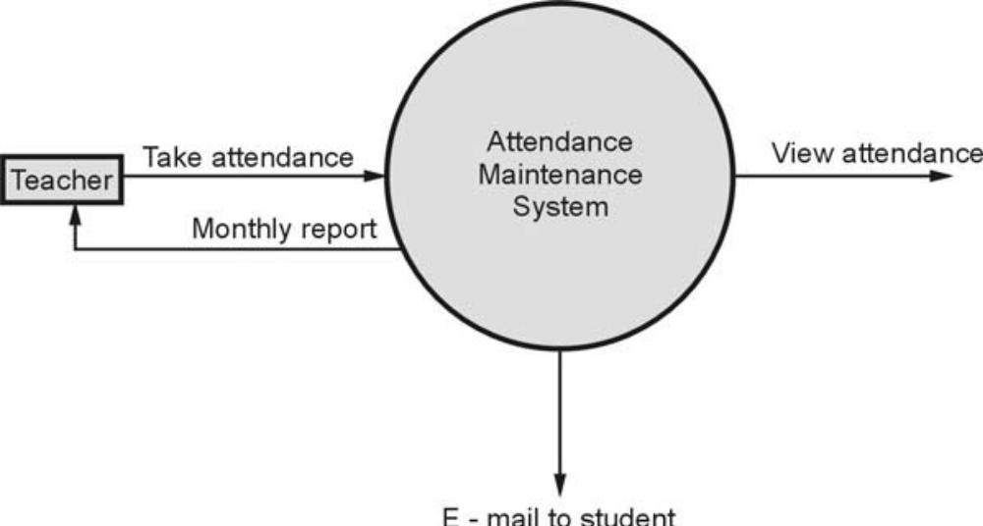
Every Teacher should have Laptop with wireless internet connection. A Teacher may
teach to different classes and a separate record for the corresponding classes should be
maintained.

2.1 User Manual
The system should provide Help option in which how to operate the system should be
explained. Also hard copy of this document should be given to the user in a booklet form.
3. Functional Requirements
3.1 Description
The identity of student is verified and then marked present at particular date and Time. The system should display student photograph along with their names for that corresponding class. The student may be marked present or absent depending upon his presence. The system should send e-mails to absent students. A statistical report should display individual’s report or a cumulative report whenever required.
3.2 Technical Issues
The system should be implemented in VC++
4. Interface Requirements
4.1 GUI
GUI 1: Main menu should provide options such as File, Edit, Report, Help.
GUI 2: In File menu one can create a new record file or can open an existing record
file. For example: If file SECOMP_SEMI_07 is opened then we may view
attendance record of SE COMPUTER class in year 2022 and a record for
Semester-I can be viewed.
GUI 3 : The display of record should be
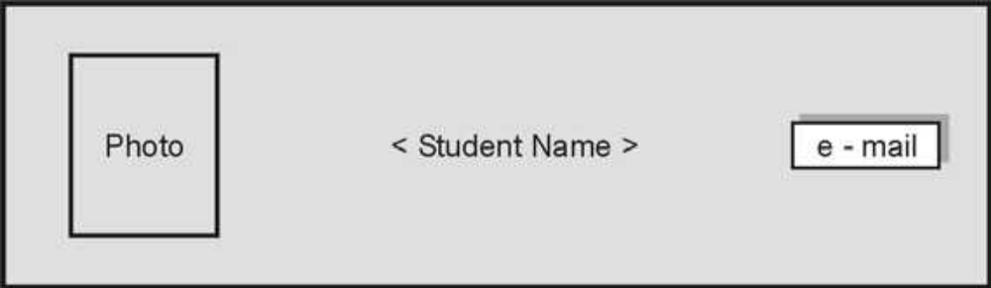
The photo can be clicked to mark student present for particular class. The
e-mail button can be clicked to send e-mail to the student being absent.
GUI 4: Report option should display statistical report. It may be for particular
student or for the whole class.
GUI 5: Help option should describe functionality of the system. It should be written
in simple HTML.
4.2 Hardware Interface
Hardware Interface 1: The system should be embedded in the laptops.
Hardware Interface 2: The laptop should use wireless Ethernet card to send e-mails.
These Laptops should be the clients of departmental database
server.
4.3 Software Interface
Software Interface 1: Attendance maintenance system.
Software Interface 2: The attendance database should be transmitted to
departmental database server.
Software Interface 3: E-mail message generator which generates standard message of absence.
Software Interface 4: Report generators
5. Performance Requirements
This system should work concurrently on multiple processors between the college
hours. The system should support 50 users.
The e-mail should be sent within one hour after the class gets over.
The system should support taking attendance of maximum 100 students per class.
6. Design Constraints
The system should be designed within 6 months.
7. Other Non-functional Attributes
7.1 Security
The teacher should provide password to log on to the system. He/she should be able to
see the record of his/her class.
The password can be changed by the Teacher by providing existing password.
7.2 Reliability
Due to wireless connectivity , reliability can not be guaranteed.
7.3 Availability
The system should be available during college hours.
7.4 Maintenability
There should be a facility to add or delete or update Teachers and students for each
semester.
7.5 Reusability
The same system will be used in each new semester.
8. Operational Scenarios
There will be student database, Teacher database. The student database will contain
students name, class, attendance, e-mail address, address, phone number.
The Teacher database will contain Teacher’s name, classes taught, e-mail address,
phone number.
9. Preliminary Schedule
The system has to be implemented within 6 months.
Importance of SRS : The software requirements provide a basis for creating the
Software Requirements Specifications (SRS).
The SRS is useful in estimating cost, planning team activities, performing tasks, and
tracking the team’s progress throughout the development activity.

